IFT 554 Middleware and Database Security

Professor Dinesh Sthapit

Trilok Navya Dubaka

1224487563

Sep 24rd 2023

Module 3 Activity 5

Reusable components -1

utility.js

export const generateRandomNumber = function(minimum, maximum){

return Math.floor(Math.random() \* (maximum - minimum)) + minimum;

}

console.log(`from utility ${generateRandomNumber(10,100)}`);

index.js

import \* as Game from './utility.js';

console.log(`from index ${Game.generateRandomNumber(10,100)}`);

Using importing External Modules (third-party modules)

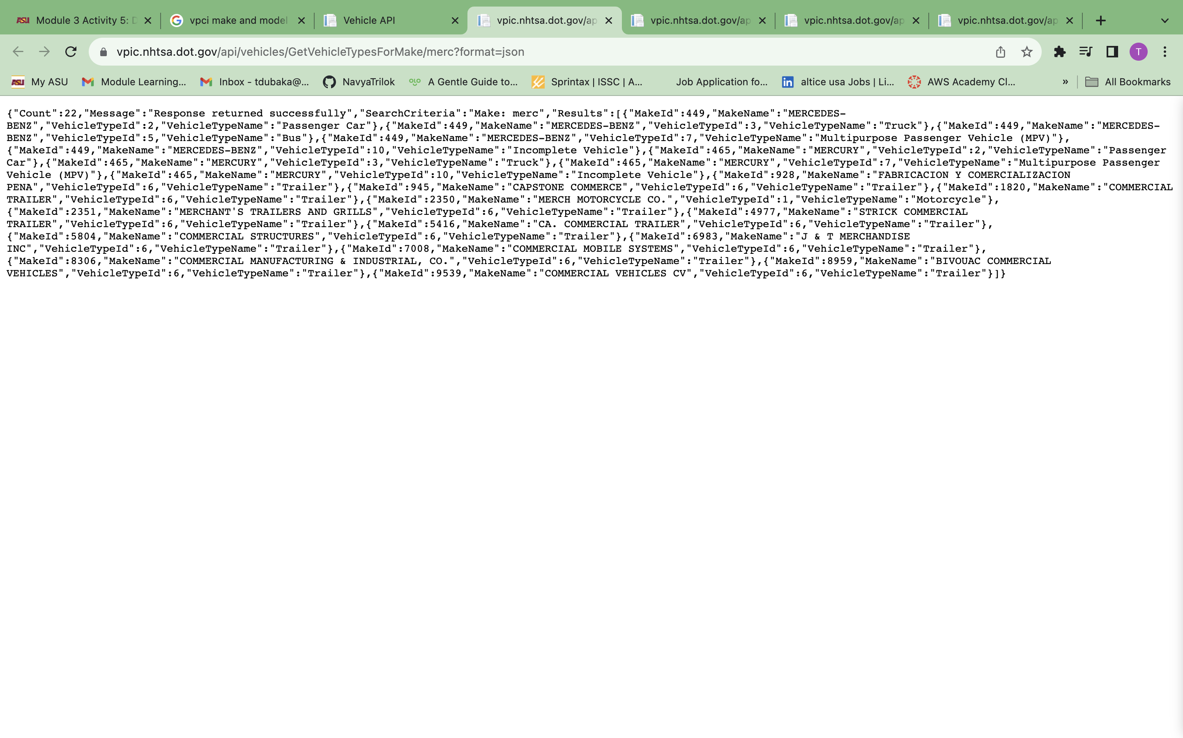

dataimports.js

var cars = [{"MakeId":449,"MakeName":"MERCEDES-BENZ","VehicleTypeId":2,"VehicleTypeName":"Passenger Car"},{"MakeId":449,"MakeName":"MERCEDES-BENZ","VehicleTypeId":3,"VehicleTypeName":"Truck"},{"MakeId":449,"MakeName":"MERCEDES-BENZ","VehicleTypeId":5,"VehicleTypeName":"Bus"},{"MakeId":449,"MakeName":"MERCEDES-BENZ","VehicleTypeId":7,"VehicleTypeName":"Multipurpose Passenger Vehicle (MPV)"},{"MakeId":449,"MakeName":"MERCEDES-BENZ","VehicleTypeId":10,"VehicleTypeName":"Incomplete Vehicle"},{"MakeId":465,"MakeName":"MERCURY","VehicleTypeId":2,"VehicleTypeName":"Passenger Car"},{"MakeId":465,"MakeName":"MERCURY","VehicleTypeId":3,"VehicleTypeName":"Truck"},{"MakeId":465,"MakeName":"MERCURY","VehicleTypeId":7,"VehicleTypeName":"Multipurpose Passenger Vehicle (MPV)"},{"MakeId":465,"MakeName":"MERCURY","VehicleTypeId":10,"VehicleTypeName":"Incomplete Vehicle"},{"MakeId":928,"MakeName":"FABRICACION Y COMERCIALIZACION PENA","VehicleTypeId":6,"VehicleTypeName":"Trailer"},{"MakeId":945,"MakeName":"CAPSTONE COMMERCE","VehicleTypeId":6,"VehicleTypeName":"Trailer"},{"MakeId":1820,"MakeName":"COMMERCIAL TRAILER","VehicleTypeId":6,"VehicleTypeName":"Trailer"},{"MakeId":2350,"MakeName":"MERCH MOTORCYCLE CO.","VehicleTypeId":1,"VehicleTypeName":"Motorcycle"},{"MakeId":2351,"MakeName":"MERCHANT'S TRAILERS AND GRILLS","VehicleTypeId":6,"VehicleTypeName":"Trailer"},{"MakeId":4977,"MakeName":"STRICK COMMERCIAL TRAILER","VehicleTypeId":6,"VehicleTypeName":"Trailer"},{"MakeId":5416,"MakeName":"CA. COMMERCIAL TRAILER","VehicleTypeId":6,"VehicleTypeName":"Trailer"},{"MakeId":5804,"MakeName":"COMMERCIAL STRUCTURES","VehicleTypeId":6,"VehicleTypeName":"Trailer"},{"MakeId":6983,"MakeName":"J & T MERCHANDISE INC","VehicleTypeId":6,"VehicleTypeName":"Trailer"},{"MakeId":7008,"MakeName":"COMMERCIAL MOBILE SYSTEMS","VehicleTypeId":6,"VehicleTypeName":"Trailer"},{"MakeId":8306,"MakeName":"COMMERCIAL MANUFACTURING & INDUSTRIAL, CO.","VehicleTypeId":6,"VehicleTypeName":"Trailer"},{"MakeId":8959,"MakeName":"BIVOUAC COMMERCIAL VEHICLES","VehicleTypeId":6,"VehicleTypeName":"Trailer"},{"MakeId":9539,"MakeName":"COMMERCIAL VEHICLES CV","VehicleTypeId":6,"VehicleTypeName":"Trailer"}];

console.log(cars[1]);

output

{

MakeId: 449,

MakeName: 'MERCEDES-BENZ',

VehicleTypeId: 3,

VehicleTypeName: 'Truck'

}

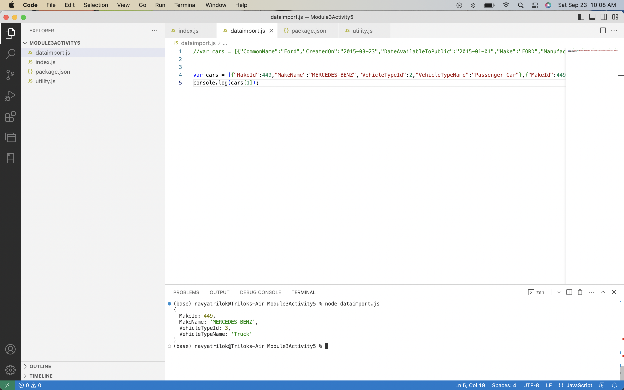

Data Formats and Data Exchange

Dataimports.js

import fetch from 'node-fetch';

const apiURL = 'https://swapi.dev/api/people'

fetch(apiURL)

.then(res => res.json())

.then(json => console.log(json));

console.log('Getting data');

Content Negotiation

contentNegotiation.js

import fetch from "node-fetch";

var query = 'https://swapi.dev/api/people/1';

fetch(query, {

method: 'GET',

header: {

'Content-Type' : 'application/xml',

'accept': 'application/json',

'User-Agent': '\*'

},

}

).then(function(response){

console.log(`response = ${response}`);

return response.text();

})

.then(function(xml){

console.log(`XML = ${xml}`);

})

.catch((error) => {

console.error(`Error:`,error);

});

